Treatment Form – Skin Needling
Title (Mr, Mrs, Miss, Ms.): .........
First Name: ...................................... Surname...............................................................
Address: .................................................................................................................................
...................................................................................................................................................
Post Code: .......................... Date of Birth.............................................................
Tel: ........................................ Mobile: ....................................................................
E-Mail: .......................................................................................................................................
I am voluntarily consenting to a skin needling procedure of the skin.
I understand that the procedure can result in an appearance enhancement and is typically used for skin rejuvenation and scar repair. The treatment uses a Dermal Roller medical device that creates controlled micro-medical needle punctures of the skin surface.
I also understand that I may require a series of Dermal Roller treatments normally with at least six weeks between procedures, to achieve the maximum cosmetic result.
I acknowledge that no written or implied verbal guarantee, warranty or assurance has been made to me regarding the outcome of the procedure.
I understand the following:
Immediately after the Derma Roller procedure the skin will be red, resembling moderate sunburn, as the skin naturally heals the redness will resolve. The skin may remain red for three to four days after the Derma Roller treatment, although it is usual for it to subside within two days and many people are able to return to their normal activities the same or next day.
It is recommended that the use of soaps on the treated skin area is restricted until the redness subsides and where possible warm / tepid water and / or gentle skin cleansers are used for cleansing. If you are taking any medication or dietary supplements that can affect platelet function and bleeding time, the period of redness can be extended.
There is a small risk of infection of the treated skin area after the Derma Roller procedure, although this is not expected to occur due to the sterility of the Derma Roller medical device and the minimally invasive nature of the micro-medical needles. Derma Roller procedure can cause areas of bruising although this would not normally be expected to occur, the eye contour being the area at most risk.
Any such bruising will be temporary. If you are taking any medication or dietary supplements that can affect platelet function and bleeding time, the severity and period of bruising can be extended, also the presence of petechiae (small red or purple spots beneath the skin) may be observed.
There is a small risk that hyper-pigmentation of the skin can occur after the procedure, although this is not normally expected as the epidermis of the skin is not removed as a result of the procedure. Failure to follow the sun exposure and sun protection advice detailed below can increase this risk.
Please ensure you understand the potential complications and personal requirements of the Dermal Roller procedure indicated below and please acknowledge or answer the points and questions:
 | YES | NO
Are you allergic to local anaesthetics, do you have a history of anaphylactic shock (severe allergic reactions)?
Do you consent to the use of a local anaesthetic?
Do you suffer from any known allergies? If yes, please specify on the next page of the is form.
Have you taken oral retinoids (Roaccutane) in the last 12 months?
Are you using topical retinoids/Vitamin A products?
Do you have active acne with papules or pustules?
Are you taking Aspirin, Warfarin, other anti-coagulant treatments or any other medication or dietary supplements such as Omega-3 that can affect platelet function and bleeding time?
Do you have or have you had any form of skin cancer?
Are you taking/receiving steroids, chemotherapy or radiotherapy?
Are you taking any other medication? If Yes, please specify on the next page of this form.
Do you suffer from any illness e.g. diabetes, angina, epilepsy, hepatitis, auto immune disease?
Do you suffer from keloid or hypertrophic scars?
Do you have a history of herpes simples (cold sores) or other skin infections?
Have you undergone a laser resurfacing or skin peel in the last 6 weeks?
Are you pregnant or is there any possibility that you are pregnant?
Are you breastfeeding?
Will you refrain from intensive sunlight exposure and/or artificial UV exposure for a period of at least 2 weeks?
Will you use topical sun protection products with an SPF 30+ or higher and with stated UVA/UVB protection on a daily basis with regular applications for the same period?
Additional comments:

I confirm that to the best of my knowledge that the information that I have supplied is correct and that there is no other medical information I need to disclose.
I understand that the practice of medicine and surgery is not an exact science and therefore that no guarantee can be given as to the results of the treatment referred to in this document. I accept and understand that the goal of this treatment is improvement, not perfection, and that there is no guarantee that the anticipated results will be achieved.
Patient/Client Signature: ................................................................. Date: .......................
Practitioner Signature: ..................................................................... Date: .......................
Date |  |  | I have read the consent |  |  | Signature
Treatment No. | Date |  |  | Derma Roller Batch No. |  |  | Administered By
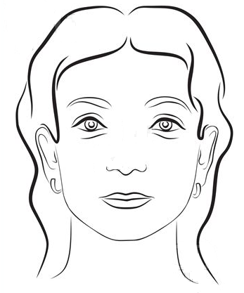
Treatment No. |  | Date |  |  | Derma Roller Batch No. |  |  | Administered By

