BEST PRACTICE

Health & Safety
Before you begin work you will need to be aware of the legislation that you must comply with for the health and safety of yourself and your clients. You will need to understand what is expected of you as a professional. This includes how to conduct yourself in front of clients and interact with fellow professionals.
Health and Safety at work Act 1974
The Health and Safety at Work Act requires all employers to provide systems of work that are as far as reasonably practical, safe and without risks to any one’s health. As an employee, you have the responsibility to take care of yourselves and others that may be affected by their work. Employees must also co-operate with their employer in this legal obligation.
As an employee, you see something which could be potentially harming, such as a hole in which a person could trip over, it is your immediate responsibility to report this to the management and to take some remedial action such as placing a sign or covering the hole, until a repair can be made. The act also requires employers to take regular risk assessments to identify potential problems, preventing accidents or injury from occurring. Health and safety is enforced by Environmental health officers who visit the workplace. Anyone who employs more than 5people must have written health and safety policies. This should identify how health and safety is managed, including individual roles staff may have, such as first aid or fire safety.
Risk Assessments
Risk Assessments should be carried out to identify what may cause harm in your workplace, who is at risk and how accidents could happen, as well as actions you need to take to prevent them. You should record all of this information and all staff should then act upon it. You can find templates for risk assessments on the website for Health & Safety Executive at www.hse.gov.uk
Management of Health and Safety at Work regulations (1999)
It is the responsibility of the employer to make formal arrangements for maintaining and improving safe working conditions and practices. This includes any training and risk assessments.
Health and Safety (Display Screen Equipment) Regulations (1992)
This covers the use of display screen equipment and computer screens. This specifies the acceptable levels of radiation emissions from the screen, as well as identifying the correct posture and number of rest periods.
Provision and use of Work Equipment Regulations (1998)
This states any duties for any users of equipment. It identifies the requirements in selecting and maintaining suitable equipment, as well as the training and safe use of it.

The Regulatory Reform (Fire Safety) Order (2005)
All premises must have adequate means of dealing with a fire and all members of staff should know where these are. This can include fire extinguishers and blankets; however, you should only operate a fire extinguisher if you have been properly trained to do so. All equipment should be checked and maintained regularly. Fire drill notices should be clearly displayed and should inform people of what do to in case of a fire. All staff should be trained in location of alarms, exits and meeting points.
Manual handling operations Regulations 1992
The HSE (Health & Safety Executives) have drawn attention to musculoskeletal disorders caused by lifting and handling with an unsuitable posture, causing pain and injury. The regulations require that training in lifting and handling are performed to prevent such injury’s occurring.
Cash Handling
Under the health and safety at work act, failure to provide a safe system of cash handling could lead to prosecution of the employer. For example, employers should consider this before sending a member of staff to the bank with cash as it is putting them in a potentially unsafe situation.
PPE – Personal Protective Equipment at Work Regulations 1992
This act covers equipment and protective clothing to ensure the safety for all in the workplace. This act also states that personnel must have training in the use of such protective measures.
RIDDOR – Reporting of Injuries, Diseases or Dangerous Occurrences Regulations 1995
This regulation states that if anyone dies, is seriously injured in an accident at work, or is off work for longer than 3 days as a result of an accident at work the employer must report it to the local authority environmental health department. Employers must keep a record in an accident book of any accident or disease. For legal reasons, eve minor accidents should be recorded so that there can be an agreed record of what occurred and what action was taken.
Performing Rights PPL & PRS
If recorded music is played on the premises, and heard by members of the public, then it is necessary to have a license from the phonographic Performance Ltd (PPL) which like the PRS (Performing Right Society) collects License payments as royalties distribution to certain copyright performers and record companies. This includes music on television channels, radios, CD’s, MP3 Players.
COSHH – Control of Substances Hazardous to Health Regulations 1994
This law requires employers to control exposure to hazardous substances in the workplace. Most products used in the salon are reasonably safe, however could become hazardous under certain conditions, or if are used in-correctly. Every therapist should be trained on how to use and store these products correctly. It is the Employers responsibility to assess the risk of hazardous substances and decide on any action to reduce the risks.
Gas Safety (installation & Use) Regulations 1994
This regulation relates to the use of and maintenance of gas supplies. The rights of entry regulations 1996 gives GAS and HSE inspectors the rights to enter premises and order the disconnection of dangerous and unsafe appliances. All work undertaken on Gas appliances should be done by registered engineers.
Electricity at Work Regulations 1989
This regulation ensures the safety in the use of electricity. Part of this act is the operation and maintenance of electrical equipment in the salon. Equipment should be tested regularly (every 6 months) to ensure that all flexes and fuses are functioning properly. This does not necessarily need to be an electrician. Most salons have their equipment tested on an annual basis and are certified this is known as portable appliance testing (PAT).
Local Government (Miscellaneous Provisions) Act 1982
Part 8 of the act provides local authorities with powers for the registration of persons who are performing skin piercing (ear piercing, acupuncture etc). It applies to everyone whether working from a salon or mobile. Each local authority operates its own methods of inspection and licensing at its own cost. Fees vary depending on your location.
Trades Description Act 1968 (Amended 1987)
This Act prohibits the use of false trade descriptions. Whether your own claim, or repeating of a manufacturers description, a false claim can be equally liable.
Sale of Goods Act 1979 & Sale and Supply of Goods Act 1994
These acts cover consumer rights including goods being satisfactory quality and the conditions in which the goods may be returned after purchase, and whether the goods are fit for their purpose.
Consumer Protection Act (1987)
This act aims to protect the consumer from unsafe or defective services or products. All staff should be trained in the treatments they carry out and the equipment used in the salon.
Cosmetic Products Safety Regulations 1996
These regulations were made under the Consumer Protection Act 1987 and implement EEC regulations regarding labeling, composition, marketing and description of cosmetic products.
Employers Liability (Compulsory Insurance) Act 1969
This act ensures that all employers take out and maintain approved insurance policies with authorised insurance bodies for bodily injury or disease sustained by their employees during their employment. Insurers must issue a certificate of insurance to employers who are required to display the certificate (or a copy) at each place of the business.
Treatment Liability Insurance
Attention is drawn to the risks which are insurable under a treatment liability policy. To provide treatments or to advise without such insurance cover may result in the therapist whether employed or not suffering heavy financial penalties. Employees who do not have their own insurance must ensure that they are covered by their employer’s policy.
Data Protection Act 1984
If a computer is used to record client data information the establishment must be registered under this act. The act operates to ensure the information is only used for the purposes that it was given. No information may be given to an outsider without the client’s permission. The client whose information is held has the right to request the information for viewing. It must be provided to them within 40 days of an application and of a fee not exceeding 10.00. Clients can seek compensation though court for any infringement of their rights. For more information visit: www.ico.gov.uk
First Aid at Work
(The Health & Safety First Aid Regulations 1981)
Employers have a legal duty to make arrangements to ensure their employees receive immediate attention if they are injured or taken ill at work. It is essential that they receive immediate attention and that an ambulance is called in serious cases. A person within the workplace should be appointed to take charge of the first aid arrangements. These regulations do not require employers to provide first aid for anyone other than their own employees.
Sharps Injuries
Employers must have a sharp injuries policy in place, to ensure employees are following the correct protocol to ensure minimal risk of needlestick injury.
What are sharps? -'Sharps' are needles, blades (such as scalpels) and other medical instruments that are necessary for carrying out healthcare work and could cause an injury by cutting or pricking the skin.
What is a sharps injury? - A sharps injury is an incident, which causes a needle, blade (such as scalpel) or other medical instruments to penetrate the skin. This is sometimes called a percutaneous injury.
What to do if you receive a sharps injury
If you suffer an injury from a sharp which may be contaminated:
- Encourage the wound to gently bleed, ideally holding it under running water
- Wash the wound using running water and plenty of soap
- Don't scrub the wound whilst you are washing it
- Don't suck the wound
- Dry the wound and cover it with a waterproof plaster or dressing
- Seek urgent medical advice (for example from your Occupational Health Service) as effective prophylaxis (medicines to help fight infection) are available
- Report the injury to your employer.
The main risk from a sharps injury is the potential exposure to infections such as blood-borne viruses (BBV). This can occur where the injury involves a sharp that is contaminated with blood or a bodily fluid from a patient. The blood-borne viruses of most concern are:
- Hepatitis B (HBV)
- Hepatitis C (HCV)
- Human immunodeficiency virus (HIV).
The transmission of infection depends on a number of factors, including the person's natural immune system. We know the number of injuries each year is high, but only a small number are known to have caused infections that led to serious illness. However, the effects of the injury and anxiety about its potential consequences, including the adverse side effects of post-exposure prophylaxis can have a significant personal impact on an injured employee.

Equal Opportunities
The equal Opportunities Commission states that a workplace must have a written equal opportunities policy which includes a statement on the commitment to equal opportunities by the employer. All employees should be aware of this policy. Equal opportunities mean that you cannot discriminate against anyone upon the basis of their sex, race disability etc.
Disability Discrimination Act (1996)
You should ensure that clients are not discriminated against on the grounds of a disability. You cannot use this as a reason to refuse to provide a treatment or service, you cannot provide a lesser service or fail to make reasonable adjustments. The premises must be able to facilitate access for disabled people.
The Equality Act (2010)
This act gives disabled people important rights of access to everyday services. Service providers have an obligation to make reasonable adjustments to premises or to the way they provide a service. Sometimes it just takes minor changes to make a service accessible.
Smoking
All areas of work in the UK should now be smoke free by law. If you do have a smoking area, this should be clearly marked. You should display signs prohibiting smoking within your business.
Laundry
All uniforms, towels and couch covers should be laundered with a detergent at a minimum temperature of 60 degrees centigrade and then tumble dried on a hot setting. If your towels are white they can be washed on the hottest setting your machine will allow. Never let towels stand while wet.
Hand Washing
Remember to always wash your hands before and after every treatment. This should involve a thorough 20 to 30 second wash of the hands and wrists using hot water and liquid soap, followed by drying with paper towels or hand drier. Certain areas of the hands are more prone to harboring microorganisms. These are between fingers, the finger tips, the thumb and back of the hand and wrist.
Waste
Anything contaminated with human tissues (blood, bodily fluids, excretions, swabs) should be designated as a group A clinical waster under the Environmental Protection Act 1990 and the Controlled Waste Regulations 1992.

Professionalism & Code of Ethics
Each professional organisation should produce its own code of ethics based on expected standards of behavior. These are referred to as a professional code of ethics. They are not mandatory but help towards maintaining high standards in the industry. Any individual within the organisation should:
- Always work within the law
- Never treat, or claim to be able to treat a medical condition
- Respect client confidentiality
- Show respect for other professions (chiropodist etc)
- Maintain high standards of Safety & Hygiene
- Apply certain treatments only with written consent from a GP
- Support and show loyalty to other professional beauty therapists
- Never poach another therapist’s client
- Maintain a professional manner
- Respect client’s modesty

Personal Appearance & Professionalism
Taking care of your personal appearance is important for presenting a professional image, and maintains good standards of hygiene. Always ensure that your skin, hair and nails are clean always. Your uniform should also be clean and well presented. What you choose to wear should be functional and present a professional image of yourself. Comfortable smart shoes are recommended. Hair should always be clean, tidy and tied back when necessary. Jewelry should be kept to a minimum to avoid it being damaged or causing harm to a client during a treatment.
Nails should be kept neat and short, particularly when offering hands on treatments such as massage or facials. Always make sure your hands are washed before and after every treatment. Remember that you are an advertisement for your business.
Personal hygiene is very important when working closely with clients. Make sure that you shower and use deodorant on a daily basis. Make sure that your posture is correct when sitting or standing to prevent muscle fatigue. Uniforms should be laundered regularly.
Costs
Always ensure that the service you offer are cost effective. Make sure that you consider all your overheads, the cost of your time, your local area and clientele when setting a price for your treatment. The price you charge for your treatment should cover all overheads and include reasonable profit margins, whilst also being appealing to the public.
Personal Safety
Wherever you are working, it is important to keep safe always. If you are travelling to appointments you should ensure that your car is in good condition, ensure that it is regularly serviced. If you have an appointment with a new client, make sure you know where you are going. Plan your journey beforehand, and if possible, try to complete a practice run at an earlier date. Being able to find an address you are looking for means that you are less likely to be late. Try to park close to your client’s home, this limits the distance you need to walk alone. Try to remember not to leave valuable and equipment on show in your car. Keep your mobile phone to hand. It allows you to keep in touch with someone at home and also provides an escape if necessary for you to contact someone. You should decide if you wish to treat male clients. Lone therapists feel more comfortable working on women only, others choose to take male clients that the know. Trust your instincts and if you feel uncomfortable remove yourself from the situation.
Working from home
If you are working from home, make sure you can see who you are letting in. If you do not recognise the person or they do not confirm their name you should refuse entry. You should keep your treatment room separate from the rest of your home. If you imply that somebody else is home, clients are less likely to become aggressive. If you feel threatened in any way you should terminate the appointment and ask them to leave straight away. If you are in their home, you should leave immediately. Remember if necessary to report any incidents to the police as soon as possible. Do not let personal fears hold you back from a great career. Many therapists never come across these situations, simply remember to be in your guard and avoid dangerous situations.
Dealing with clients
When dealing with clients in a salon you should always speak clearly and concisely during a treatment. This means that your client is not disadvantaged if they are from another cultural or religious background, are a different age or gender or have disabilities. After you have completed consultation you should check to make sure that your client has understood what you have said. Your body language can also be used to demonstrate your professionalism, allowing your client to feel more comfortable when answering your questions
Insurances & Memberships
Before offering treatments to paying members of the public, you should ensure that you are fully insured. This will give you financial protection in case something goes wrong with the treatment, subject to the terms and conditions of the policy. It is also advisable to become a member of a professional body such as the guild. They offer many valuable member benefits and offer a professional code of ethics.
There are different types of insurance membership cover which therapists may require to carry our professional treatments. It is important to understand which type of insurance you need and this information can be obtained by talking to your insurance provider to ensure it meets your individual requirements.
Treatment Liability
Covers you in the event of a claim being made against you by a client who you may have injured during a treatment, examples include burns, scarring etc.
Public Liability
Covers the insured therapist in the event of a client injuring themselves whilst in the treatment room, for example tripping or slipping.

Product Liability
Covers you in the event of a client claiming that a product used in the treatment room or sold to her for home use has caused an injury or reaction.
Employers Liability
If you employ staff you will need to have by law employer’s liability insurance. Employers are responsible for the health and safety of their employees while they are at work, so this insurance is compulsory. Employers liability covers you against claims that may arise from employees if they are injured at work or suffer work related illnesses and found that you were liable.
Stock & Equipment Insurance
You may also wish to ensure your equipment and professional/retail products against damage flood or theft.
Insurance
If you are the owner of a high street salon you will need to seek information about additional insurances you may require.
GDPR
The GDPR (General DATA Protection Regulation) came into force on 25th May 2018. If you’re Salon/Business collects or stores any type of personal data from people in the EU – you will need to comply with GDPR regardless of the Brexit status at the time. If you don’t comply – there can be financial penalties.
The information you collect could include names, email addresses, contact details, postal and digital IP addresses etc. The new regulations are designed to give control of personal information back to ordinary people, prioritising them over the interests of businesses.
Therefore, it’s important for you to be aware of this new legislation and adhere to it accordingly. There are some positives – being compliant shows your audience that you are a trustworthy organisation that respects their privacy and personal information
What this means for you:
- Conduct a personal data audit. List what data you collect about your clients either through your website, consultations or through 3rd parties – basically list every single possible way you obtain client data whether that is through your website, in written form or through your mobile phone. Do you have a newsletter feature on your website? Do you operate an online store and collect customer data in order to process orders? Where is that data stored? Does it go directly to your email or stored in a database in your website? Think about whether all the data you collect is necessary. If you feel that some of the information you currently collect and store isn’t strictly necessary, you can take steps to stop collecting it and purge it from your databases.
- You will need to add a privacy policy to your site – many GDPR privacy policy templates are available by searching Google. It is suggested that you create a page in your website called PRIVACY POLICY which will appear in your main website menu. Your website must be SSL compliant – if it starts with https:// and has a padlock next to the website address in your browser then you’re fine… if not, contact your website provider to upgrade.
- Contacting all your clients making them aware of GDPR, your new privacy policy and requesting consent to be able to continue to communicate with them. You can either do this my emailing everyone and asking them to reply back confirming its ok for you to process and store their data or you can ask them to click on a link requesting them to opt-in using a newsletter facility such as mailchimp.com.
- Understand what must be done in the event of a breach. GDPR requires the data controller to have defined processes in place in the event of a data breach. The data controller has a legal obligation to report a data breach within 72 hours. For more information about this, take a look at an article on the reporting of data breaches.
- Children. GDPR, for the first time, brings in special protections for children’s personal data – particularly in regards to commercial internet services such as social media. If your organisation offers services to children and relies on consent to collect information about them, you will need to gain the parent or guardian’s consent in order to process the child’s data lawfully. GDPR sets the age at which a child can give their own consent to this processing at 16. This means that your privacy information page must be written plainly enough for a child to understand.
- Record Cards. Remember to add your disclaimer to the bottom of your record cards so that clients can opt in or out of having personal data stored. Here is an example for you to use:

I agree to YOUR BUSINESS NAME HERE obtaining, holding and using my personal information for the purposes of this consultation and suitability checking for any future treatments I may have. I understand that I have the right to withdraw my consent and have my details destroyed.
Yes/No *Please circle. Initial: Date:

Further Reading
ICO guide to GDPR. Be sure to download the GDPR 12 Step Guide

Sterilisation Methods
There are several ways to sterilise and sanitise your tools. Tools must be washed with warm soapy water before being sterilized, as sterilisation will not remove dirt/skin or product from the tools.
Sterilisation: Destruction of all living organisms.
Sanitisation: Destruction of some, but not all micro-organisms. Suitable for tools which do not come into contact with blood or bodily fluids.

Wet Sanitation: Barbicide is a diluted solution in which tools should be left for at least 15 minutes at room temperature. Barbicide is known to kill fungus, bacteria and also immune diseases such as HIV & hepatitis. This method is ideal for sanitising tools such as nail clippers, cuticle nippers, scissors and cuticle knifes.
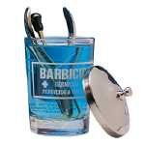

Dry Sanitation: UV Cabinets are a suitable method of keeping sterilized tools in a sterile condition until they need to be used. Implements are simply laid out under a UV light for 30minutes. The UV only kills bacteria on the surfaces it covers, so tools will need to be turned to ensure all surfaces are kept sanitised.
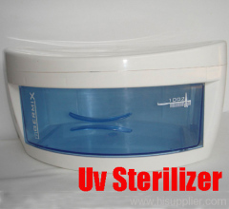

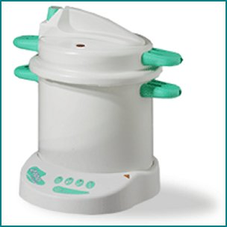
Heat Sterilisation: Autoclaves are a fantastic method of sterilisation by method of bringing implements up to extremely high temperatures of 121 degrees centigrade or more in a pressurised steam cabinet to kill any bacteria. This method is not suitable for plastic implements though – only metal! They are very costly, but very good. Another heat method is the glass bead sterilizer, a smaller cheaper alternative where tools are immersed into small glass beads that are bought up to a high temperature. Again this method is only suitable for metal implements.

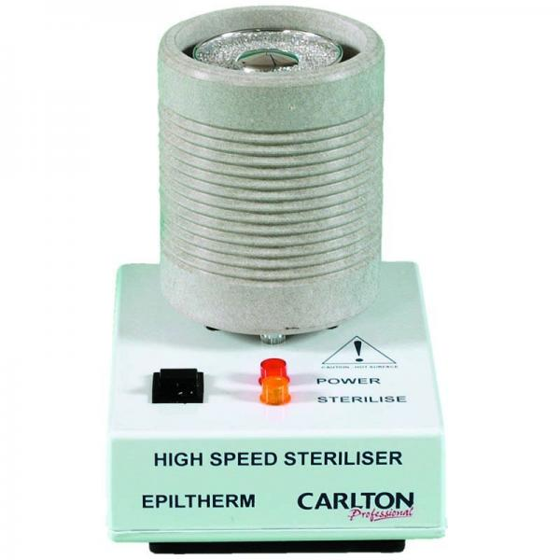
Anatomy & Physiology

The Skin
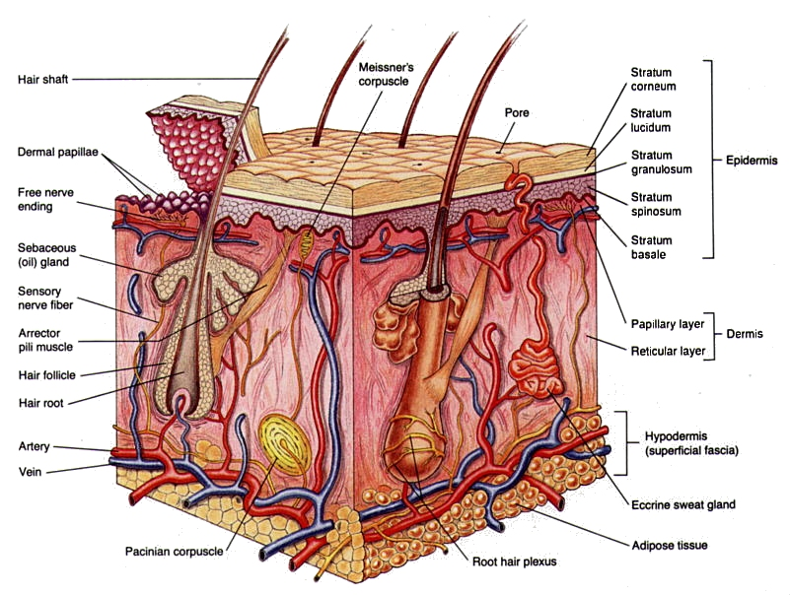

The skin is the largest organ of the body and has many varied functions. It is self-healing, and self-replacing. Our skin becomes darker in colour to protect from excessive sunlight. Skin is vital in the production of Vitamin D, and regulation of our body temperature.
Functions:
SHAPES & Vitamin D production
- Sensory
- Heat Regulation
- Absorption
- Protection
- Excretion
- Secretion

The skin has 3 main layers
- The Epidermis (Top Layer)
- The Dermis (Middle Layer)
- Subcutaneous Layer (Basal Layer).
The Epidermis is the outermost layer that you can see, and varies in thickness. This section is subdivided into 5 smaller layers:
Stratum Corneum (Horny Layer)
*25-39 Cells deep, flat dead horny keratinized cells no longer containing a nuclei. These cells are continuously rubber away and replaced by new cells from beneath
Stratum Lucidium (Clear Layer)
*Clear in appearance, the cells have no nuclei and are almost completely keratinised
Stratum Granulosum (Granular Layer)
*2 to 3 layers of cells which contain granules of keratin. This is a protein found in skin, hair and nails, horns & hooves. Keratinisation takes place and cells lose moisture and flatten
Stratum Spinosum (Prickle Cell Layer)
*8 to 10 layers of cells bonded together by threads. Blood cells and melanin move between them. Contain granules of melanin which continue to move upward with the cell
Stratum Basal (Basal Layer)
*Cell Division (mitosis) takes place continually, and the cells move upwards. It takes around 40 days for the cells to move from base layer to the surface. Nutrients are obtained from blood supply in the dermis below. Melanocytes produce skin pigment known as melanin which helps to protect the skin from harmful rays
The Dermis (Middle layer) contains sweat glands, sebaceous glands, nerve fibres, nerve endings, blood vessels, capillaries and hair follicles. Consists of two layers.
Papillary Layer
Immediately under the epidermis and contains many blood capillaries which bring fresh oxygen and nutrients to the epidermis.
Reticular Layer
Contains hair follicles which produce and grow hairs, sebaceous glands which secrete sebum providing a protective acid mantle for the skin, Apocrine sweat glands which produce sweat and are usually attached to hair follicles, eccrine sweat glands which produce a watery sweat all over the body to help temperature control (cooling the body). Receptors, nerves that sense pain, pressure hot & cold. Collagen & Elastin fibres which gives our skin strength and elasticity.
The Subcutaneous (basal layer) is under the dermis and is a layer of adipose tissue (fat cells) which act as a food store and help to keep the body warm and protect us.

The Acid Mantle
The acid mantle is a mix of sweat and sebum on the surface of the skin which acts as a protective barrier against bacteria. It also acts as a natural moisturiser and waterproof covering.
Adipose Tissue
Adipose tissue is a type of loose connective tissue containing cells which are adapted to store fat. It is mostly found under the skin and around the organs. It acts as a reserve of food and helps to maintain body temperature by preventing heat loss. Massage softens the adipose tissue and helps to disperse it into the deeper layers of tissue and circulatory system. Distribution of the fatty layer varies according to gender, age and lifestyle. Women tend to have a thicker layer then men.
The Fitzpatrick skin scale
The scale was created by Thomas Fitzpatrick, a former chairman at Harvard Medical School. He studied the sun’s effect on the skin - specifically when it came to melanoma. Your skin type can affect many different things, such as proneness to wrinkles and other visible signs of ageing, likelihood of developing acne, resistance to the penetration of UV radiation and how well scars heal. On the Fitzpatrick Scale, skin types are grouped according to the person's genetic predisposition to melanin, the chemical that gives skin its pigmentation. Dermatologists use the scale to determine risk factors for things like sunburn, skin cancer, scarring risks and hyperpigmentation.
The Fitzpatrick Scale lists six different skin types.

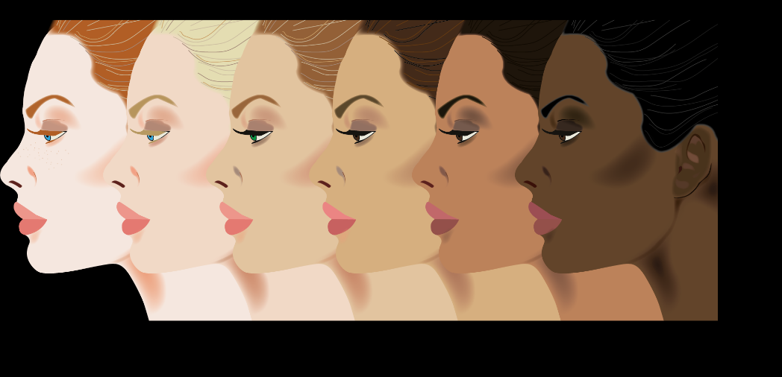

- Type 1 is the fairest and is often freckled with a naturally reddish undertone. People with Type 1 skin are likely to have blonde or red hair with porcelain or very pale skin. They are very likely to burn after sun exposure but have a low potential for scarring.
- Type 2 skin is fair or cream coloured. People with Type 2 skin tend to have light hair and blue or brown eyes and are more likely to burn than tan. The risk of scarring is low unless the wound is slow to heal.
- Type 3 skin is slightly darker than Type 2 but still fair with golden skin tones. People with Type 3 skin may have brown or green eyes and tan easily, however may burn with long exposure to the sun. Type 3 skin has a higher scarring potential than Type 1 or 2.
- Type 4 skin is described as olive or caramel toned, typically with hazel or brown eyes and dark hair. Type 4 skin tans very easily and may still burn with long sun exposure. Type 4 skin scars easily.
- Type 5 skin ranges from olive to a rich brown. People with Type 5 usually have brown eyes, dark hair and tan very easily. Type 3 skin very rarely burns but has a high risk of scarring.
- Type 6 skin ranges from deep mahogany to very dark brown. People with Type 6 skin usually have dark brown eyes and black hair, tan quickly and easily but are at very high risk of abnormal scarring.

Skin Diseases & Disorders
Skin Disease/Disorder | Image
Scabies  Looks like tiny insect bites or spots. It can be extremely itchy and is caused by small mites burrowing under the skin. Scabies can be caught very easily. | 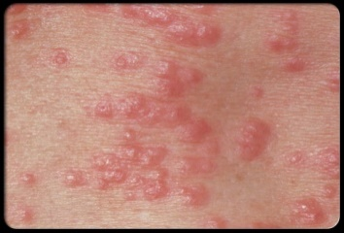
Ringworm  A fungal skin infection. Itchy red raised scaly patches in the characteristic ring shape. Spreads easily from one person to another. | 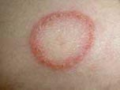
Head Lice  Wingless insects that are grayish brown in colour. They grow to aprox 3mm in length. They are spread by head to head contact | 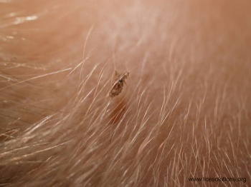
Impetigo  A bacterial skin infection of the surface skin layers causing blistering and scabbing. Highly contagious. | 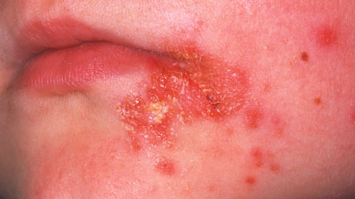
Cold Sores  Small blisters usually around the mouth on the lips. They are caused by the herpes simplex virus. Highly contagious by close contact | 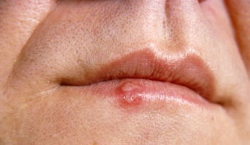
Conjunctivitis  Bacterial infection of the tissue that covers the front of the eye (conjunctiva). Itchiness, redness, swelling and weeping. Easily spread. | 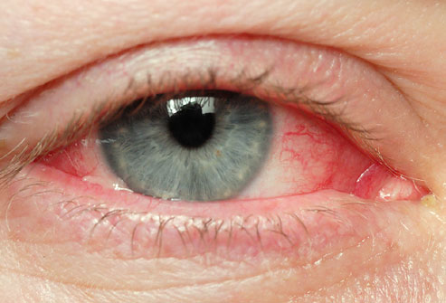
Eczema  A condition which causes dry, red, itchy and sometimes flaky skin. Common behind the knees, elbows, Side of the neck and around the eyes. The condition is not contagious, but may be irritated by some products. | 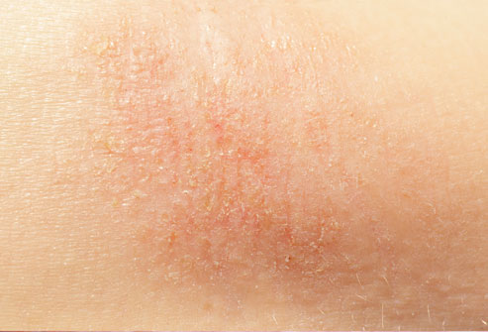
Dermatitis  Inflammation of the skin that occurs when it comes into contact with certain substances. Red, itchy, scaly kin that sometimes burns and stings. It can be Allergic or Irritant. Not contagious but may be sensitive to certain products. | 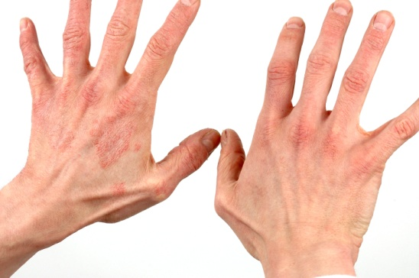
Skin Cancer  Varying skin growths. Skin cancer generally develops in the Epidermis, so the growth can usually be seen. Signs are changes to the skin that do not heal. If there is any doubt what so ever you should refer your client to see their G.P and avoid treating until you have written consent from their practitioner. | 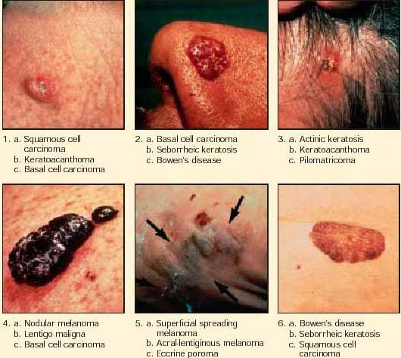
Warts  Small growths on the skin caused by the human papilloma virus. They are characterized by a cauliflower type appearance. Warts are a contagious viral condition. | 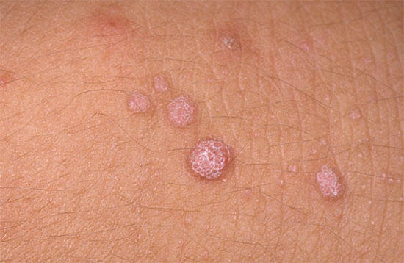

Anatomy of the face
Our face shape is created by the underlying bone and muscle structure. The skin is the largest living organ of the body and therefore should be looked after and kept well presented.
The skin is underlined by the skull,​
A skull is composed of two main parts - the cranium and the mandible.
The cranium is a series of joined bones, which allow for very little movement, and the mandible is the moving lower jaw.
Cranial bones:
- Frontal bone
- Two parietal bones
- Sphenoid bone
Collectively, these bones provide a solid bony wall around the brain, with only a few openings for nerves and blood vessels.
Facial Bones
The 14 bones that support the muscles and organs of the face are collectively known as our facial bones.
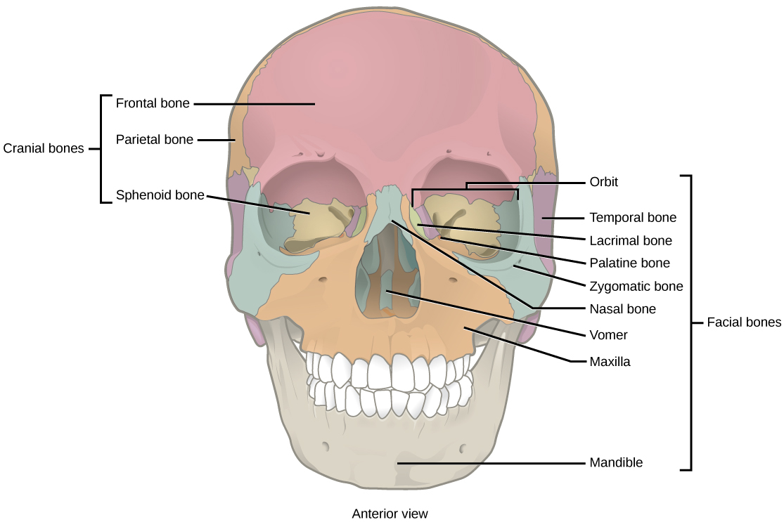
The facial bones consist of:
- Mandible
- maxillae (singular: maxilla)
- Vomer
- palatine bones
- nasal bones
- zygomatic bones
- nasal conchae (singular: concha)
- lacrimal bones
- Temporal bone
- Orbit

Facial Muscles
The facial muscles include
- Frontalis
- Occipitalis
- Epicranial aponeurosis
- Temporalis
- Orbicularis oculi
- Masseter
- Splendours capitus
- Sternocleidomastoid
- Buccinator
- Zygomaticus
- Platysma
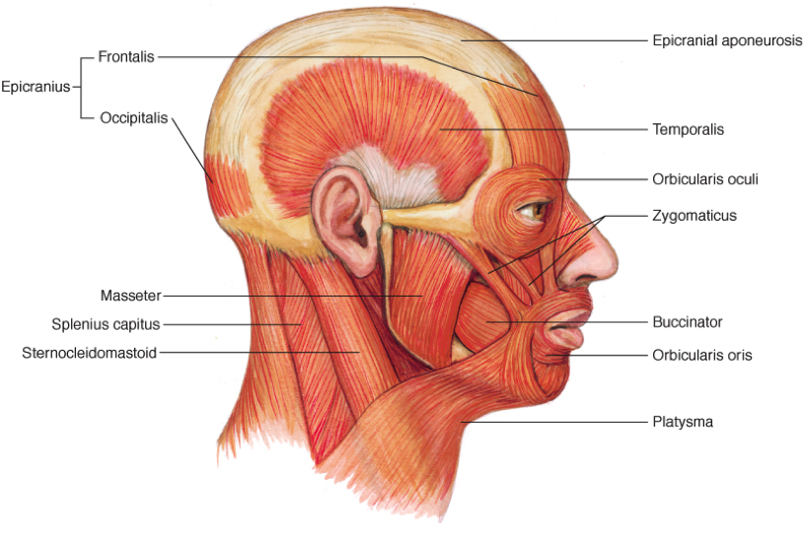

Consultation
A consultation is a one to one discussion with your client which allows you to find out the important and confidential information that will help you advise and give clients the best treatment.
Always introduce yourself to your client and treat clients a whole taking into consideration general well-being, i.e. health, emotional, physical and mental states. You need to explain clearly why you are carrying out a consultation.
Within your consultation it is important to make the most out of your session, not only getting to know your client but getting to know their requirements for treatment, this is done through visual observation, verbal questioning and physical examination.
Use open questions to encourage your client to give you information without them feeling interrogated, this will allow you to connect with your client and offer them the best possible solution which will match their criteria, work together to set an objective for the treatment.
Client Notes Date:

Name
Address and postcode
Date of Birth
Age

Gender

Mobile number
Email address

Confidential medical questionnaire | Please answer Yes or No. If yes, please explain
Do you have any medical problems? (Asthma, diabetes, heart problems etc…)
Do you have any autoimmune conditions, cancers, blood disorders, neurological conditions, muscle disorders, facial problems or skin conditions? (Bells palsy, epilepsy etc…)
Are you currently under the care of a doctor, clinic, hospital or specialist?
Are you taking any medications? If so, which ones.
Are you allergic to anything? (Medications, latex, pollen etc…)
Are you or could you be pregnant, breastfeeding or undergoing IVF?
When did you last have any aesthetic treatment?

Treatment Plan
Treatment plan

Notes

Practitioner signature:
Date:

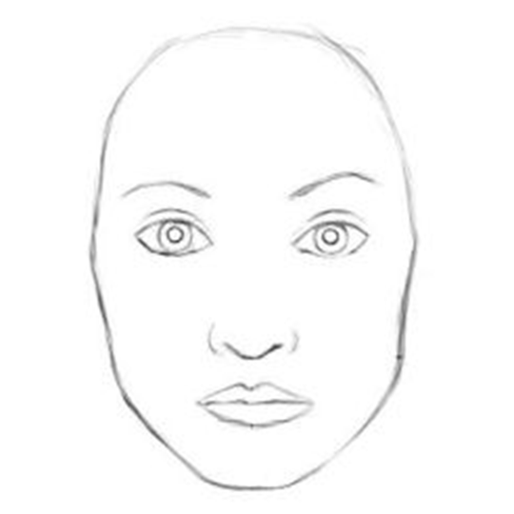Areas treated

Medication / Products used
Expiry dates
Lot numbers
Practitioner signature
Date
Notes (All notes must be dated and signed).

